* Pre-requistie softwares required to installed in our system to create 'Book Registry' application.
  + Visual Studio Code
  + Node.js
  + MongoDB
* We are creating 'Book Registry' web application using node.js, express, MongoDB, and React JS.
* Open the “**Book_Registry_Backend**” folder using Visual studio code.
* Install express, mongoose and cors by typing the following command in the terminal:
  + **npm i express mongoose cors**
* Install nodemon globally by typing the following command in the terminal:
  + **npm i -g nodemon**
* Run the “backend” project by using below command in the terminal
  + **nodemon index**
* Open the “**Book_Registry_Frontend**” folder using Visual studio code
* Install react-router-dom, axios, and bulma by typing the following command in the terminal:
  + **npm i react-router-dom axios bulma**
* Install react-datepicker component
  + **npm install react-datepicker --save**
* Run the frontend project by using below command in the terminal
  + **npm start**
* When the application runs, the **Homepage** loads showing the features to view the list of BookUsers, books, users in the database and also to create new records respectively.

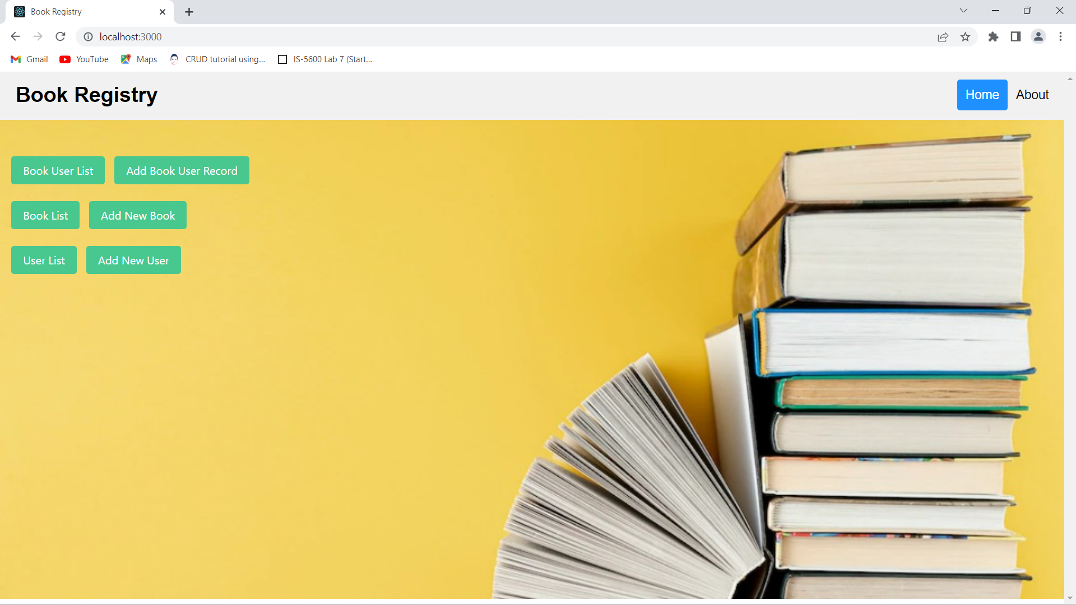

* **About** Page explains the Book Registry application features.

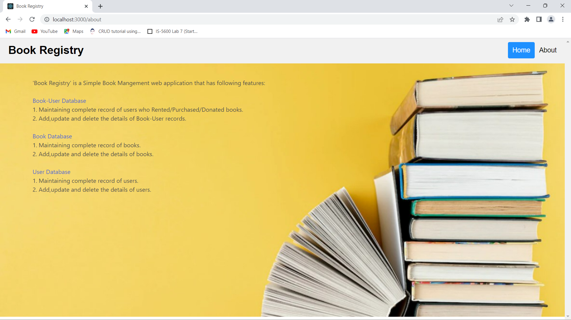

**Book details – Add/Update/Delete**

1. Lets begin by adding new book record “The Lord of the Rings” by clicking on ‘Add New Book’ on Home page.

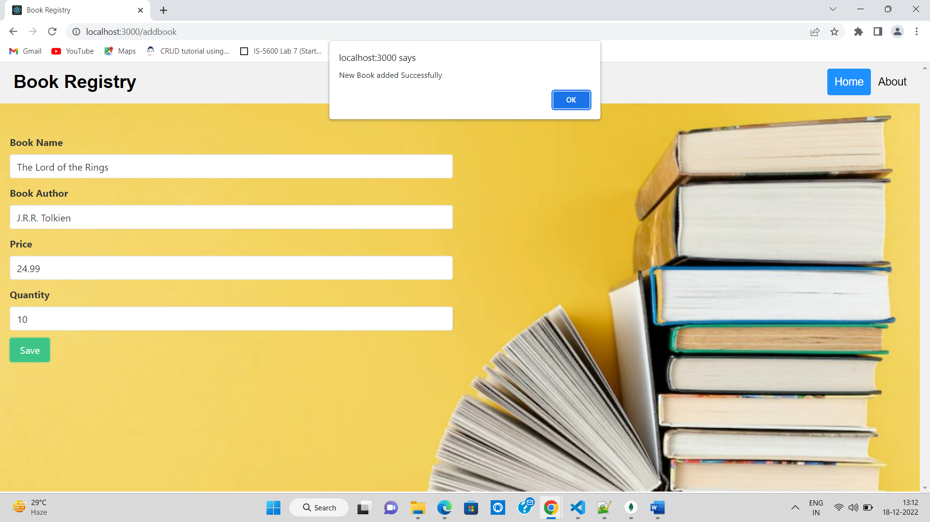

1. We can see the record inserted in **books** table in the ‘BookRegistry_db’ database.

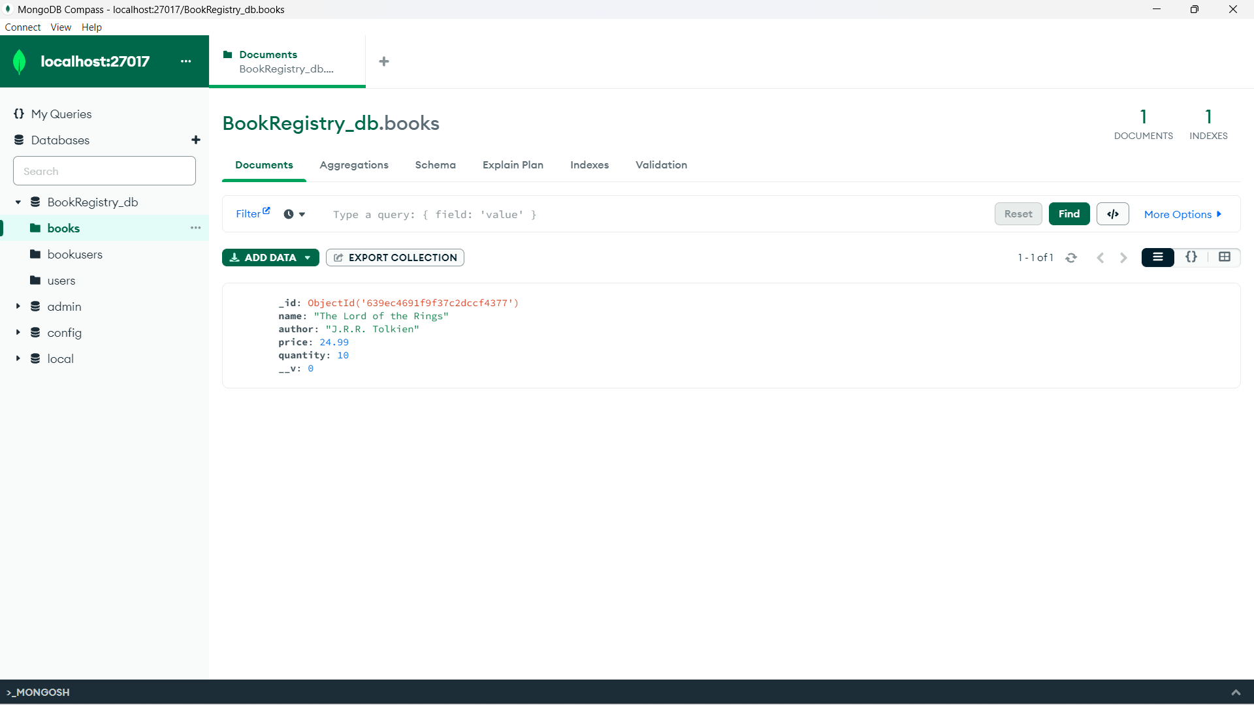

1. The inserted record can be seen in the **Book List** section.

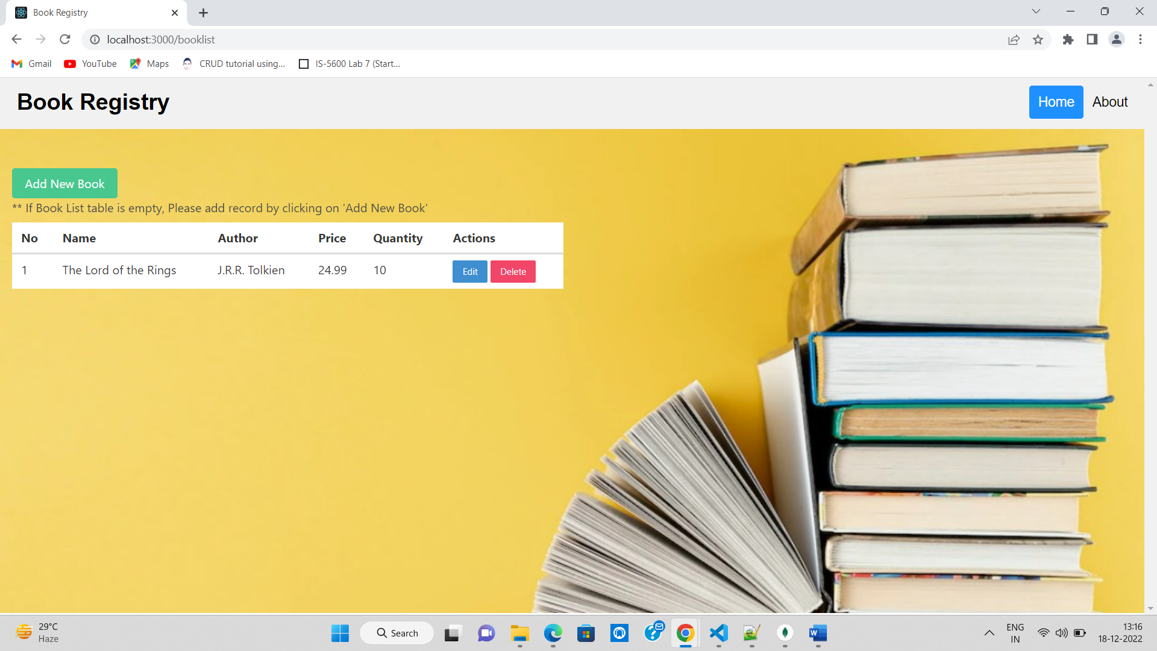

1. Now we are updating the **Quantity** of existing record from 10 to 20 by clicking on ‘Edit’ button.

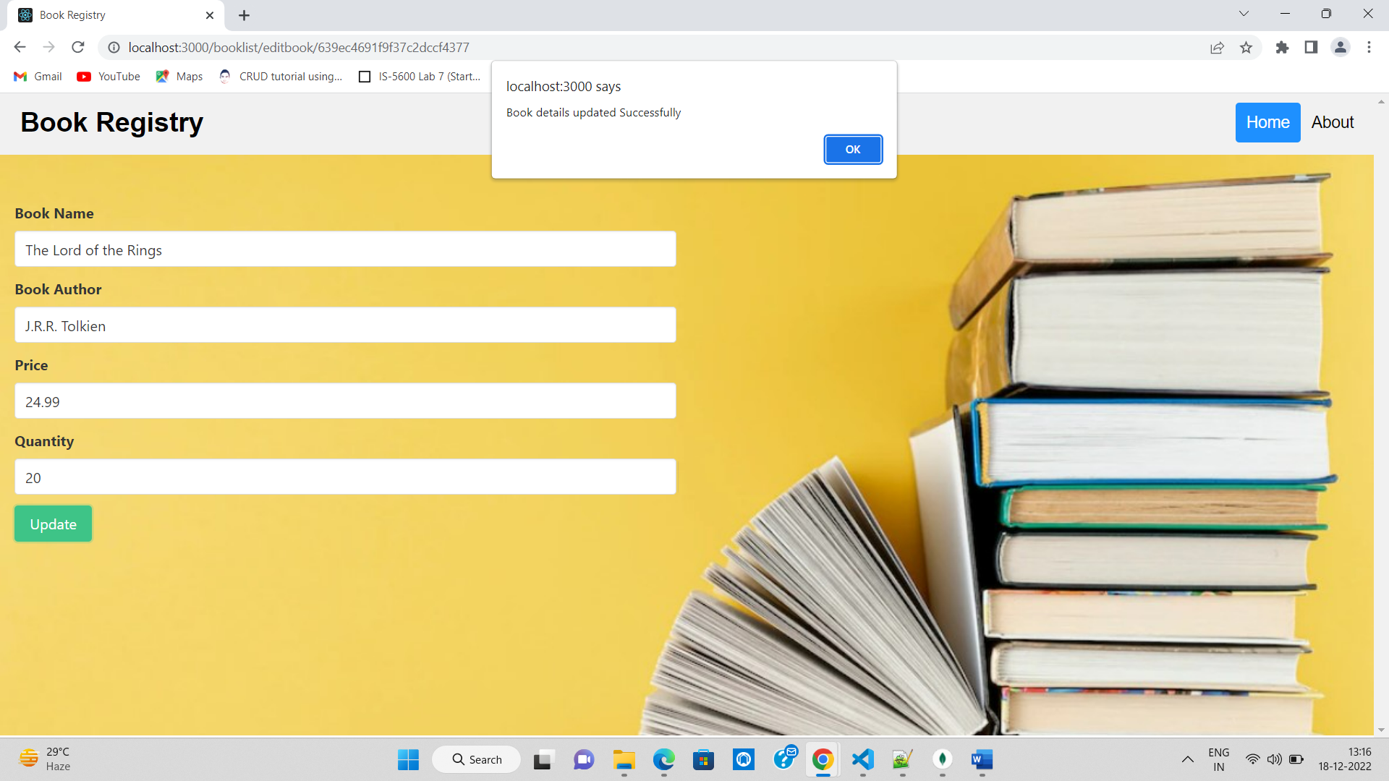

1. The updated record reflects in the database.

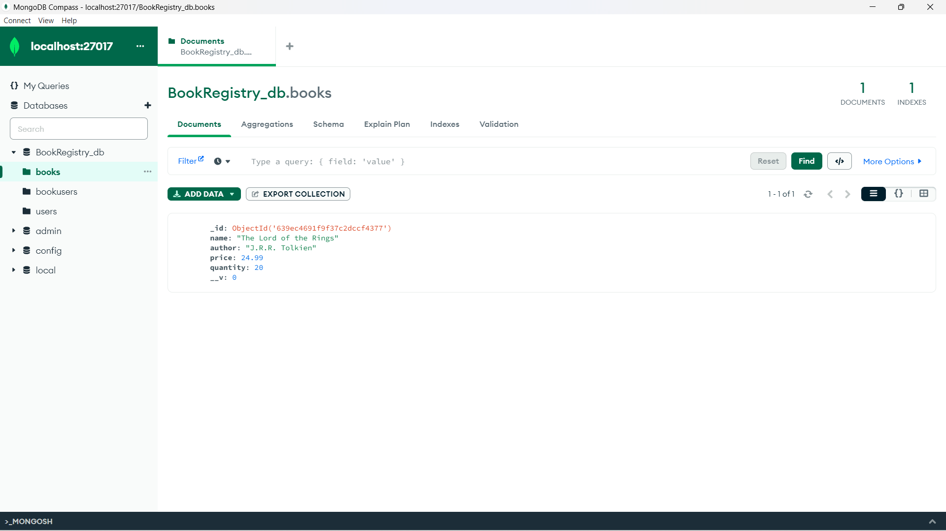

1. We have added new book record to the database “The Kite Runner”.

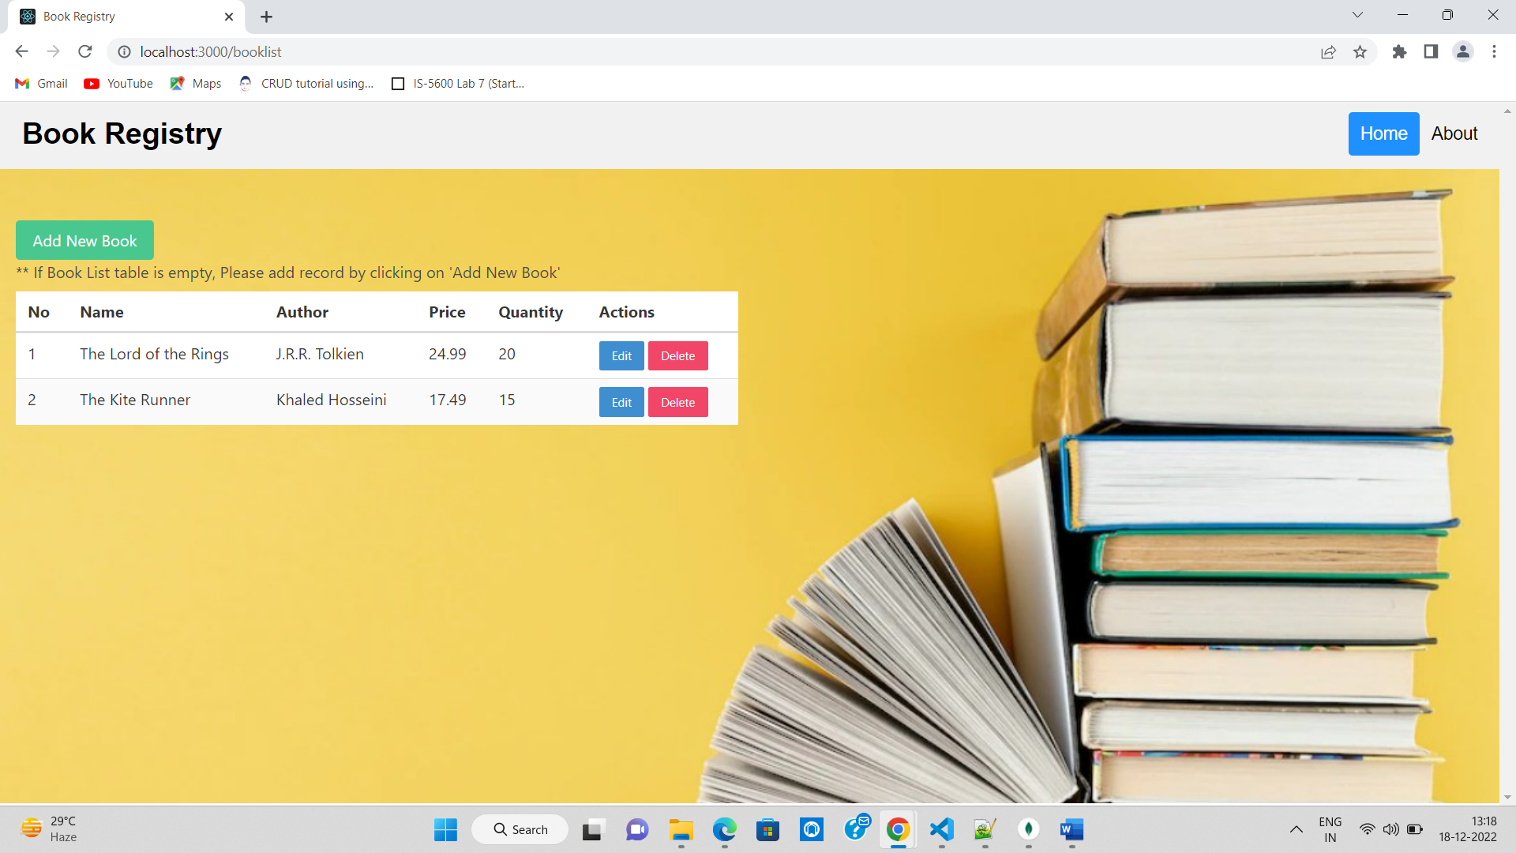

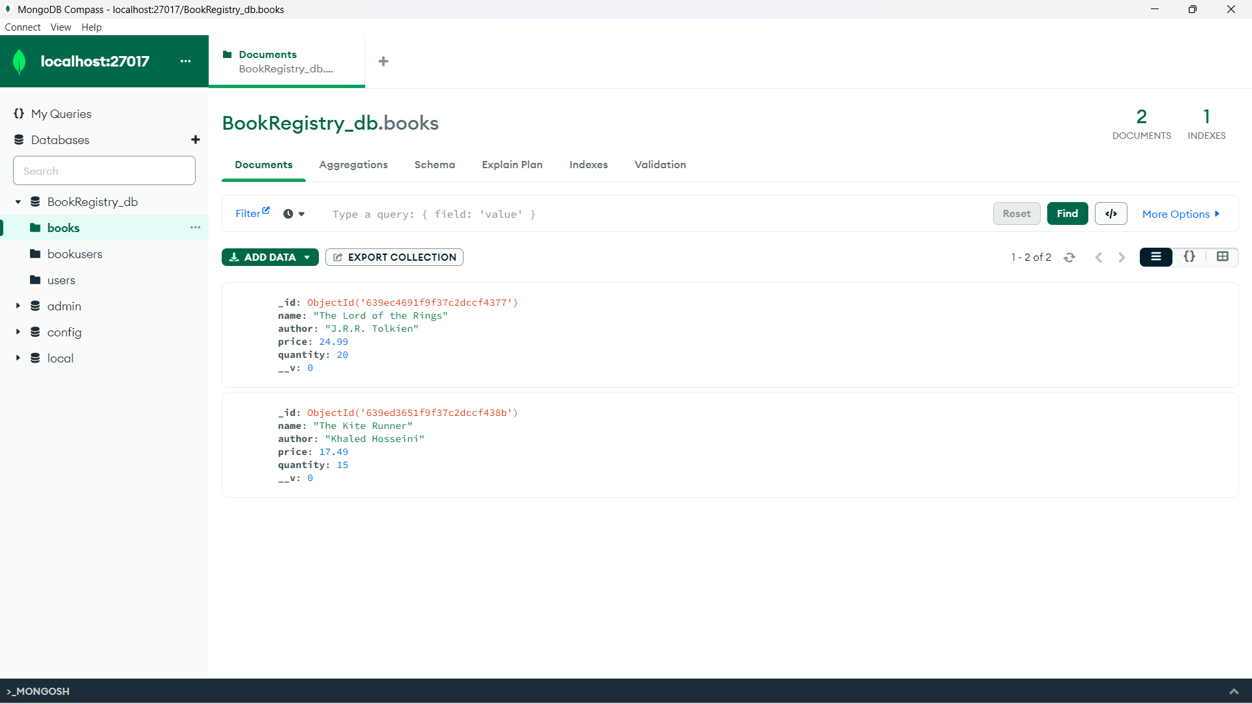

1. We have deleted “The Lord of the Rings” by clicking on **Delete** button.

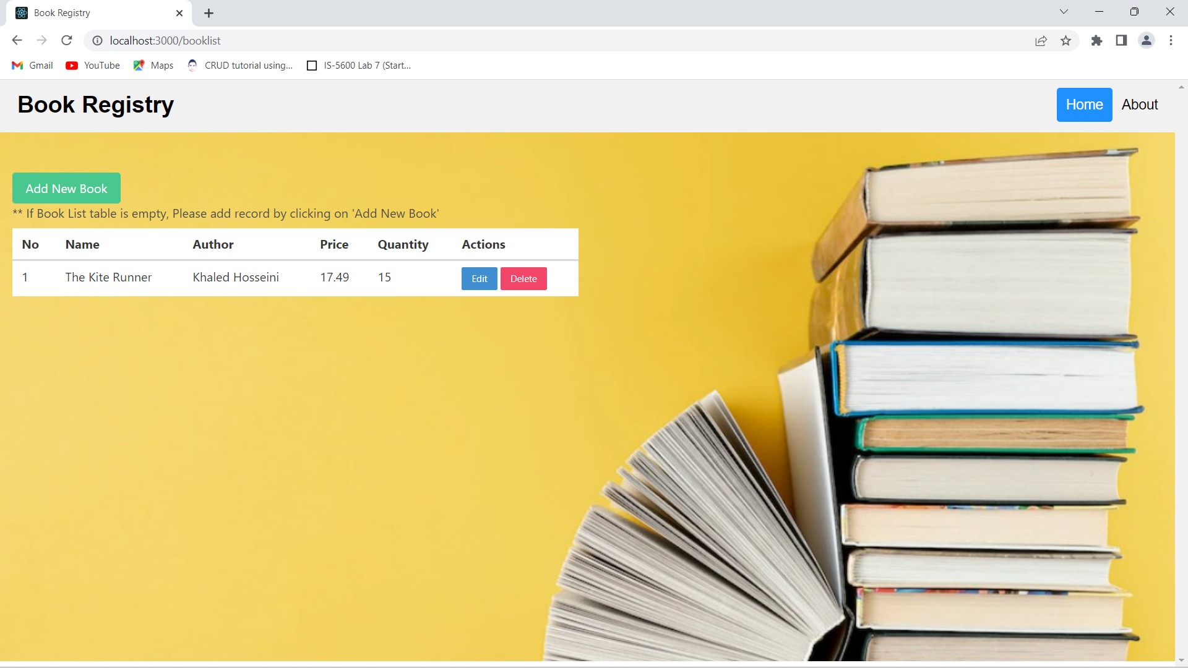

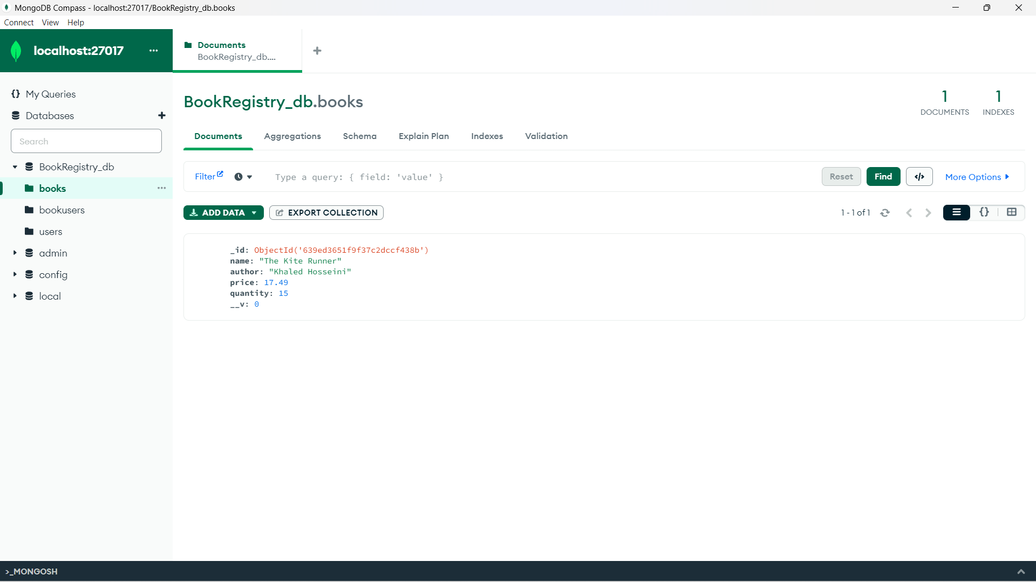

**User details – Add/Update/Delete**

1. Let’s add new user ‘James Clark’ by clicking on ‘Add New User’ on Home page.

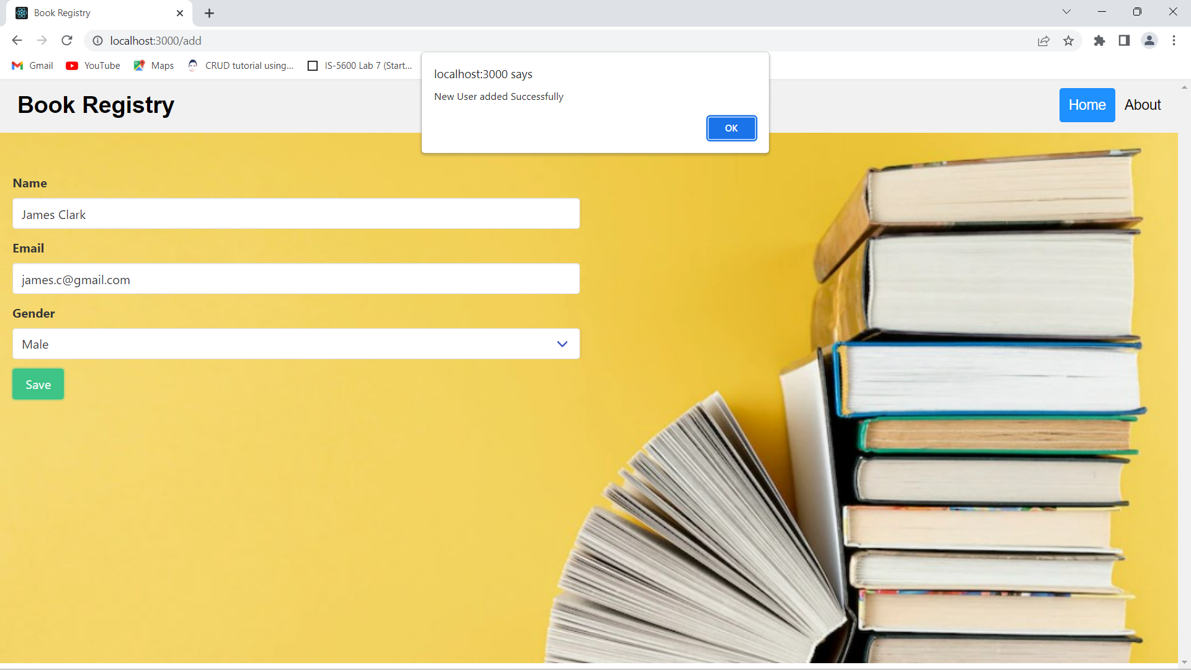

1. We can see the record inserted in **users** table in the ‘BookRegistry_db’ database.

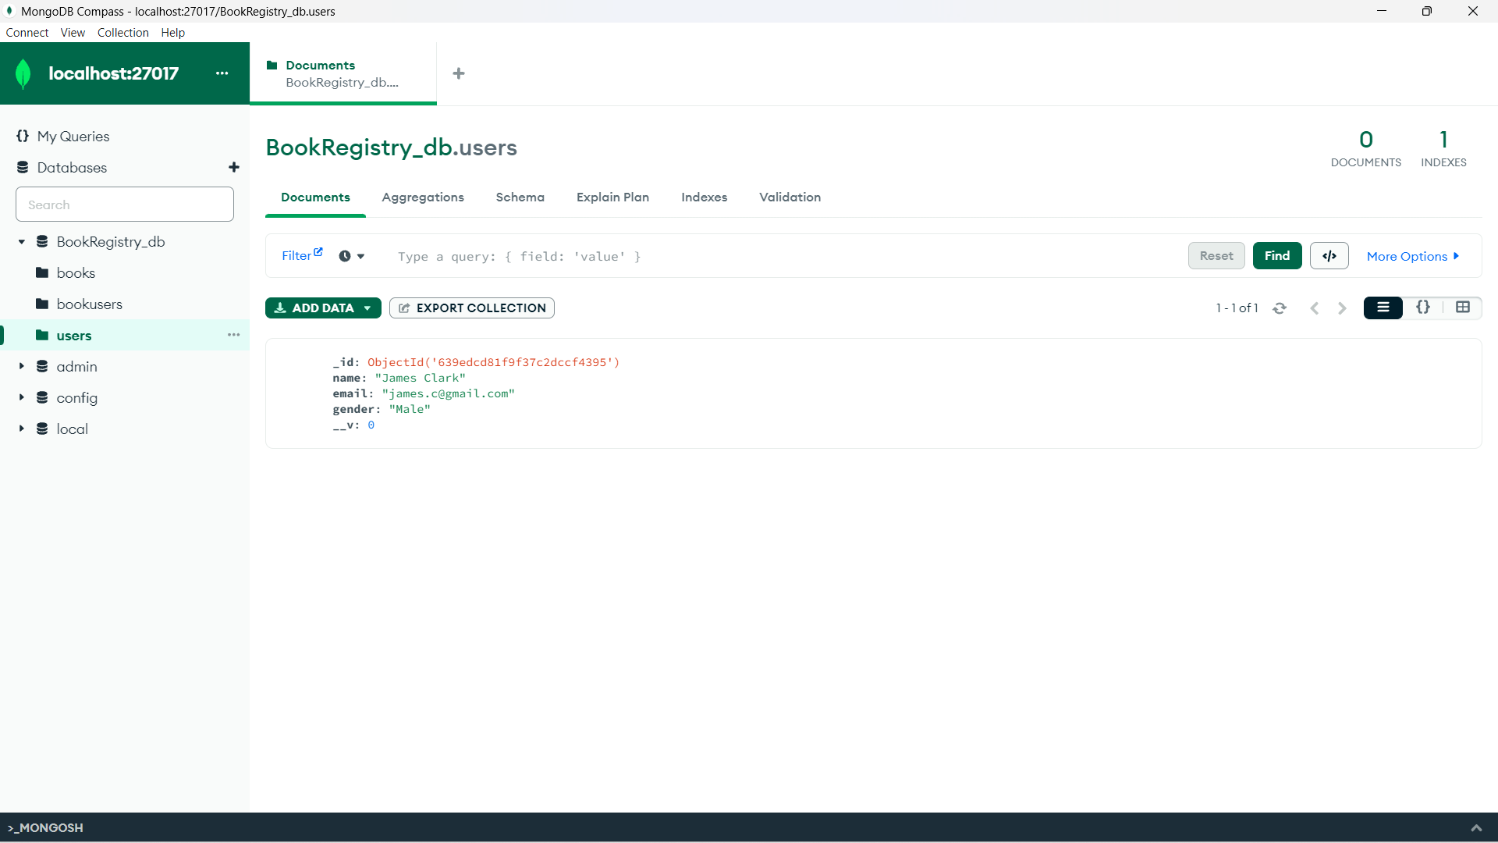

1. The inserted record can be seen in the **User List** section.

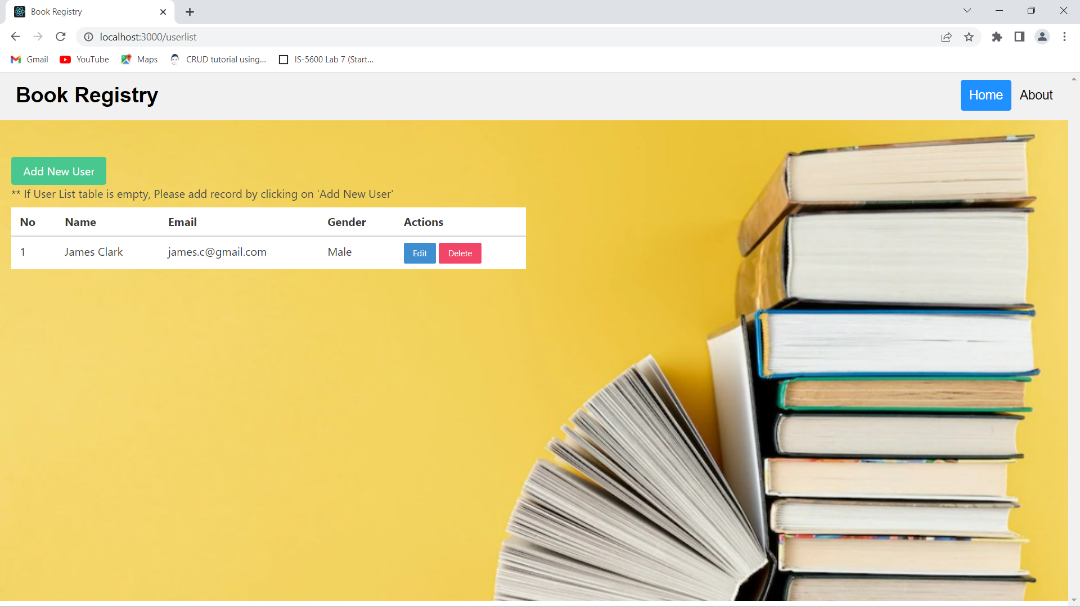

1. We have updated user’s email to ‘james.clark@yahoo.com’ from james.c@gmail.com

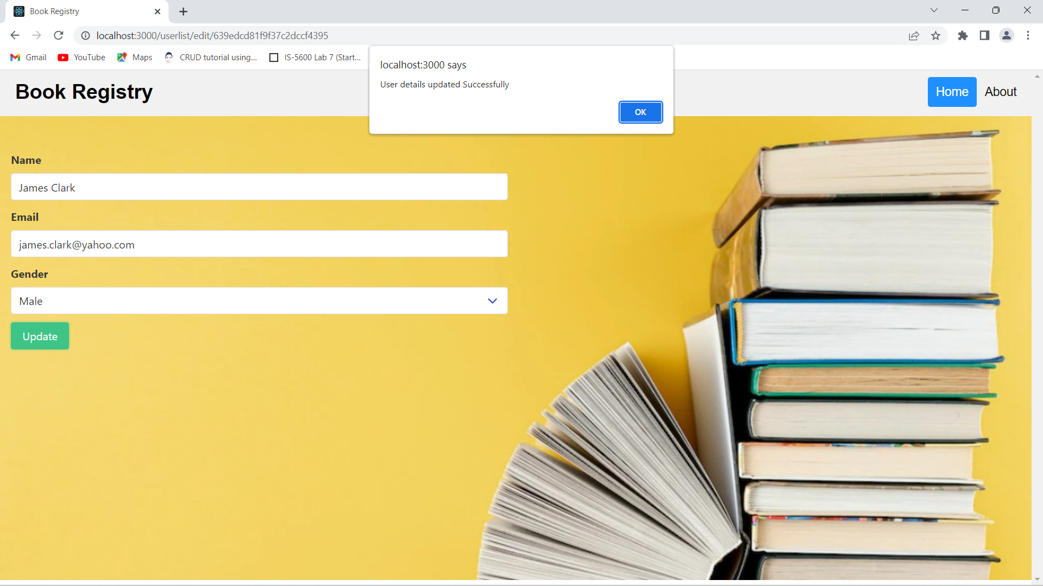

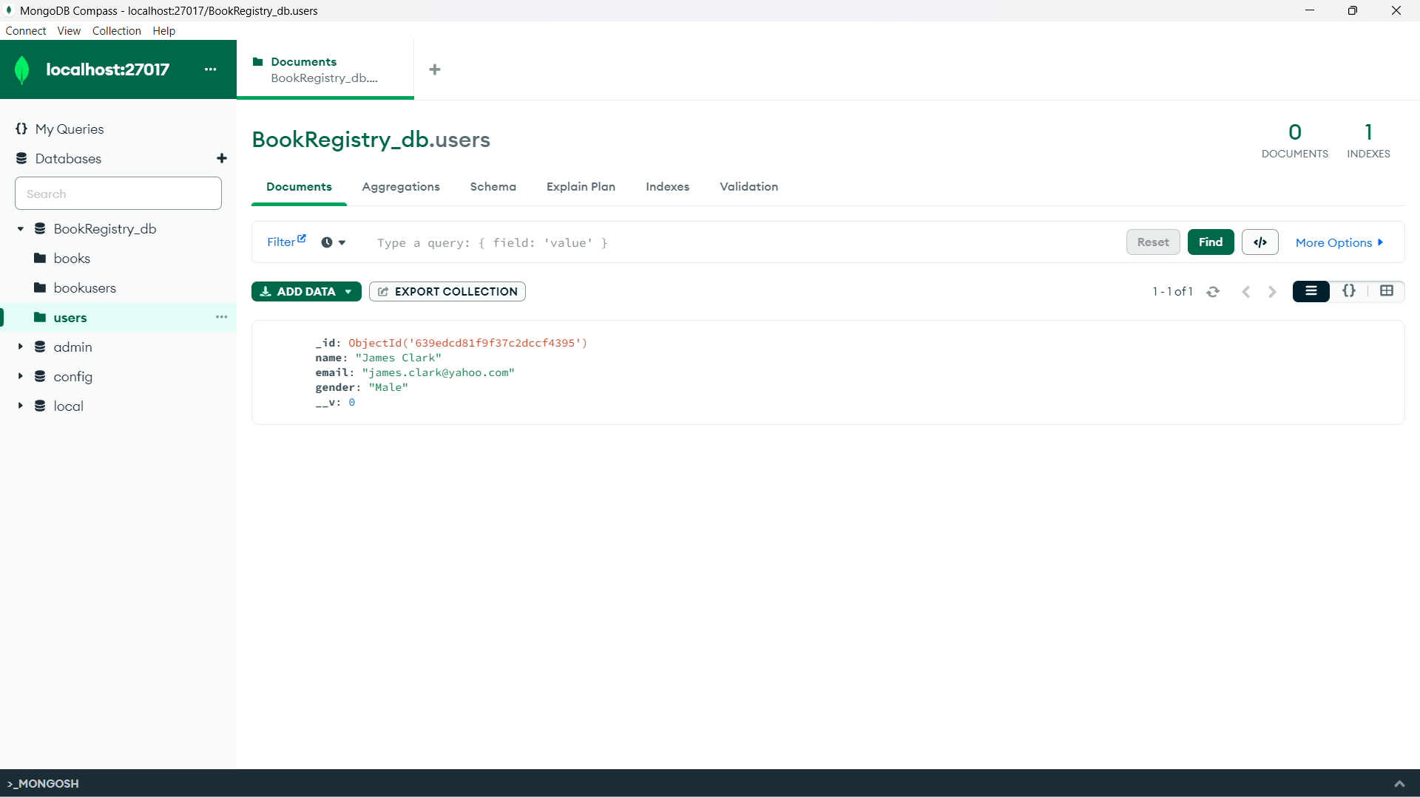

1. We have added new users ‘Mary Beth’ and ‘Maria Linda’.

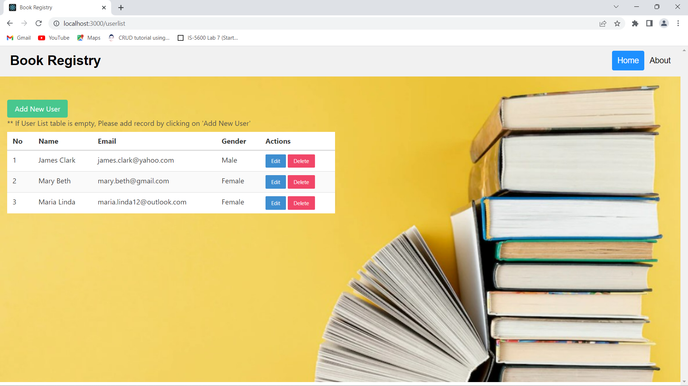

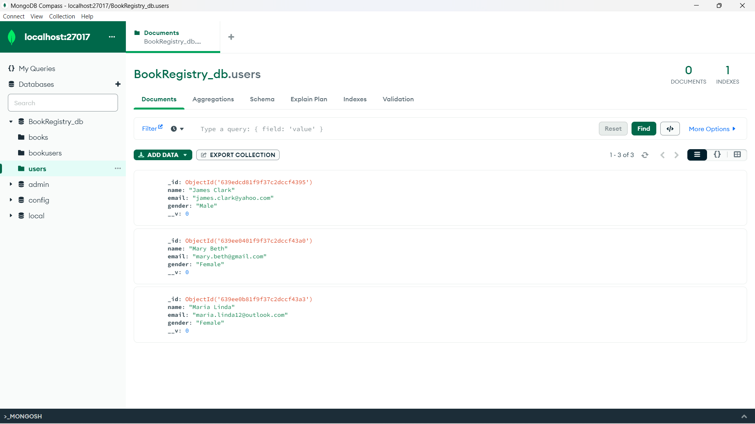

1. Now let’s delete ‘Mary Beth’ from the list by clicking on **Delete** button.

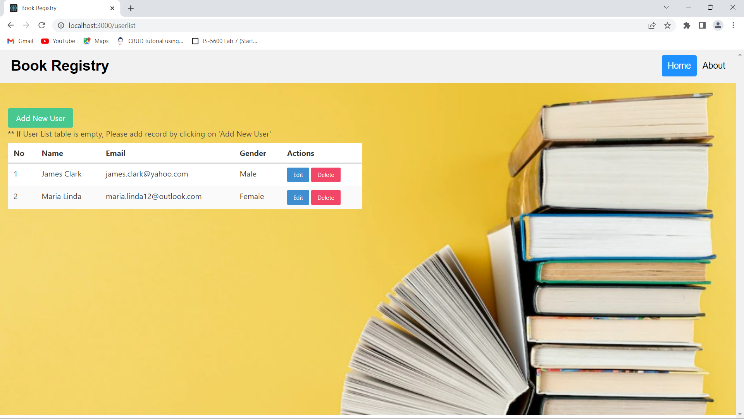

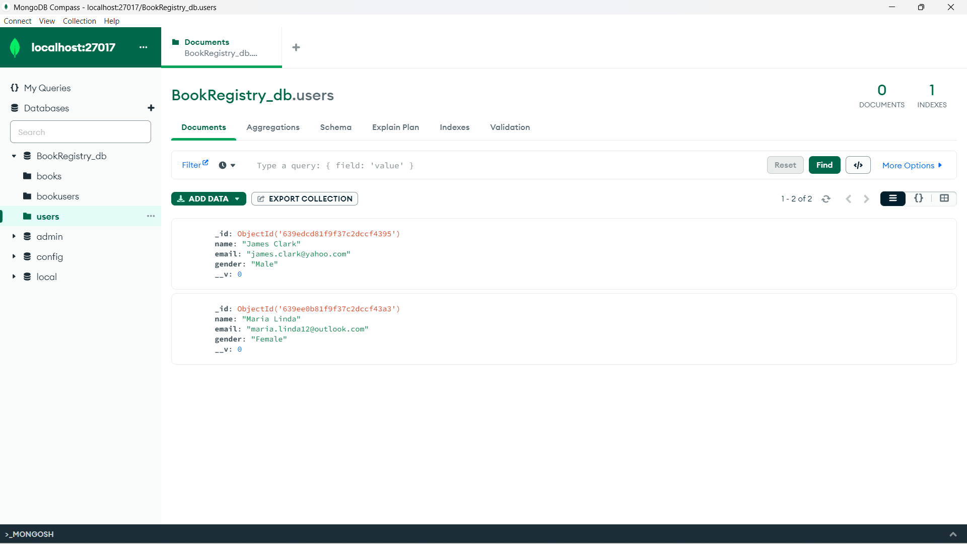

**Book - User details – Add/Update/Delete**

1. Lets insert a record of the user who Rented/Purchased/Donated books by clicking on   
   ‘Add Book User Record’ on Home page.
   1. In Book Name dropdown we are fetching books from database
   2. In User Name dropdown we are fetching users from database

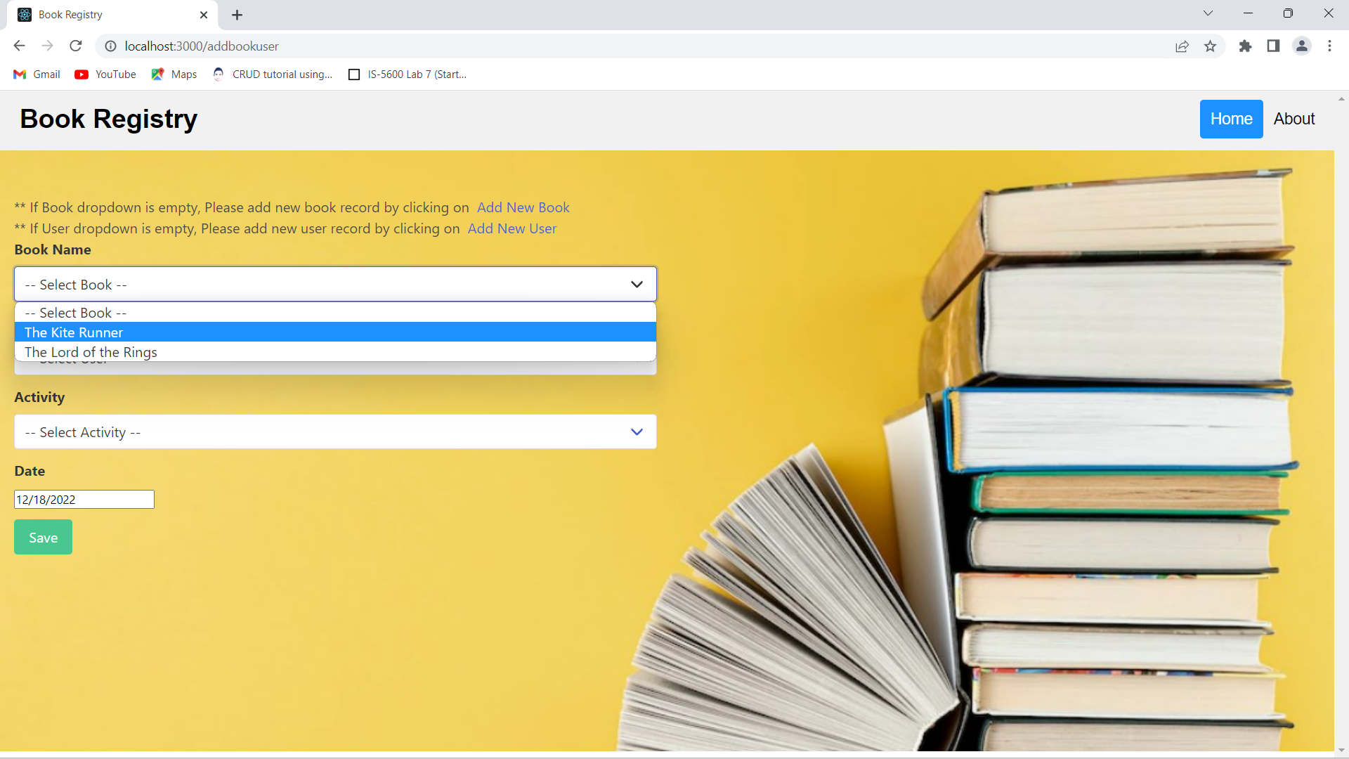

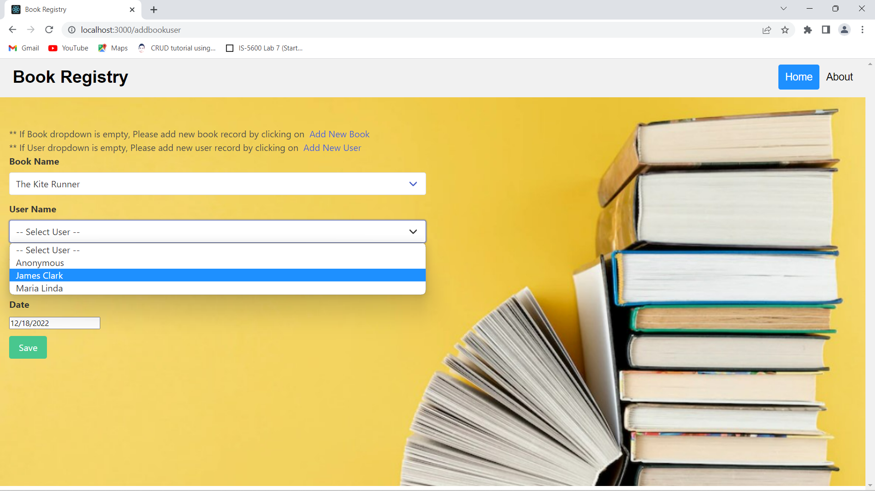

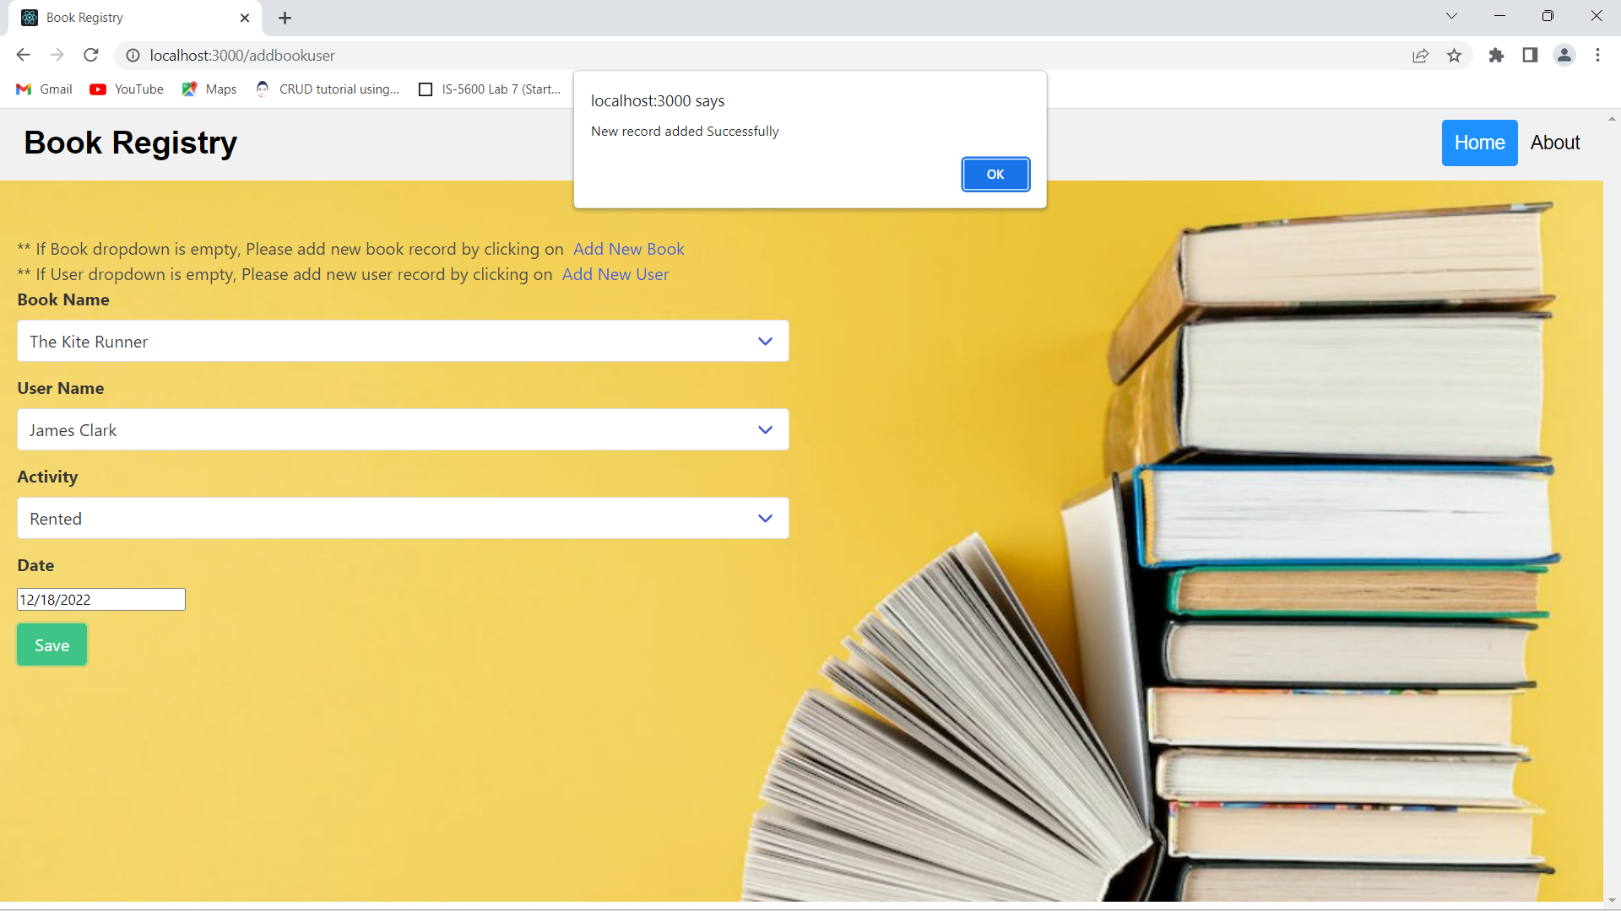

1. We can see the record inserted in **bookusers** table in the ‘BookRegistry_db’ database.

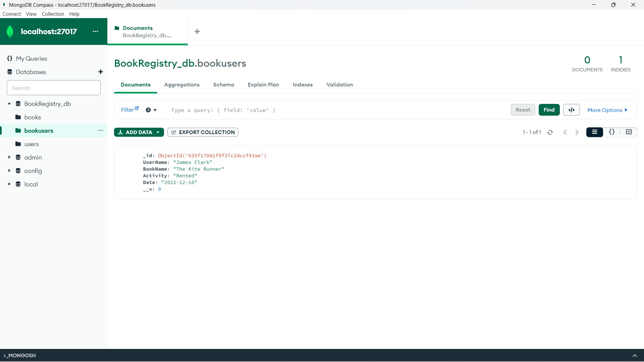

1. The inserted record can be seen in the **Book** **User List** section.

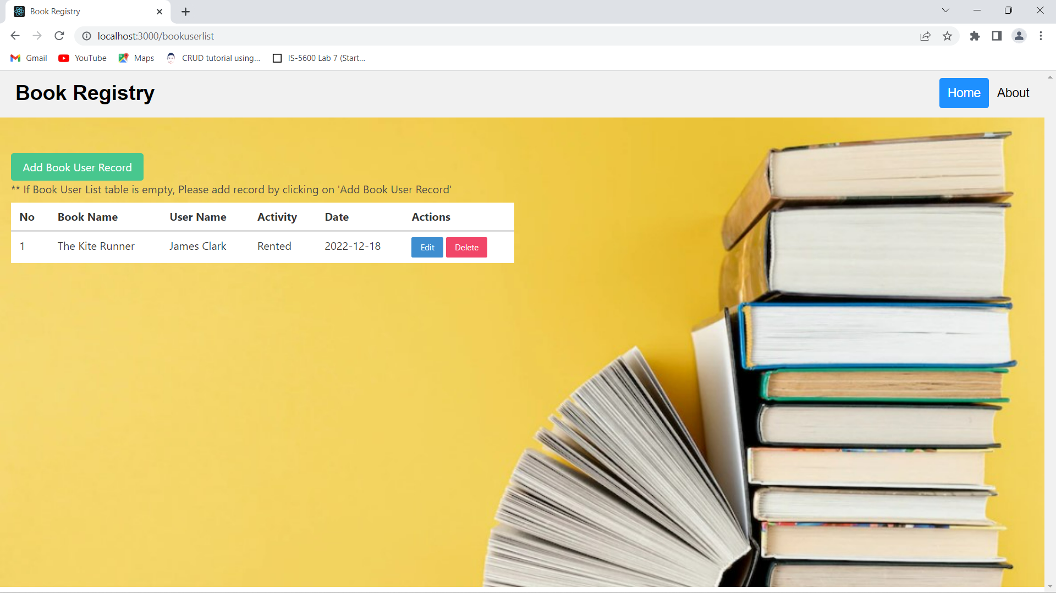

1. We have updated user’s activity of ‘The Kite Runner’ book to ‘Purchased’ from ‘Rented’ and also date.

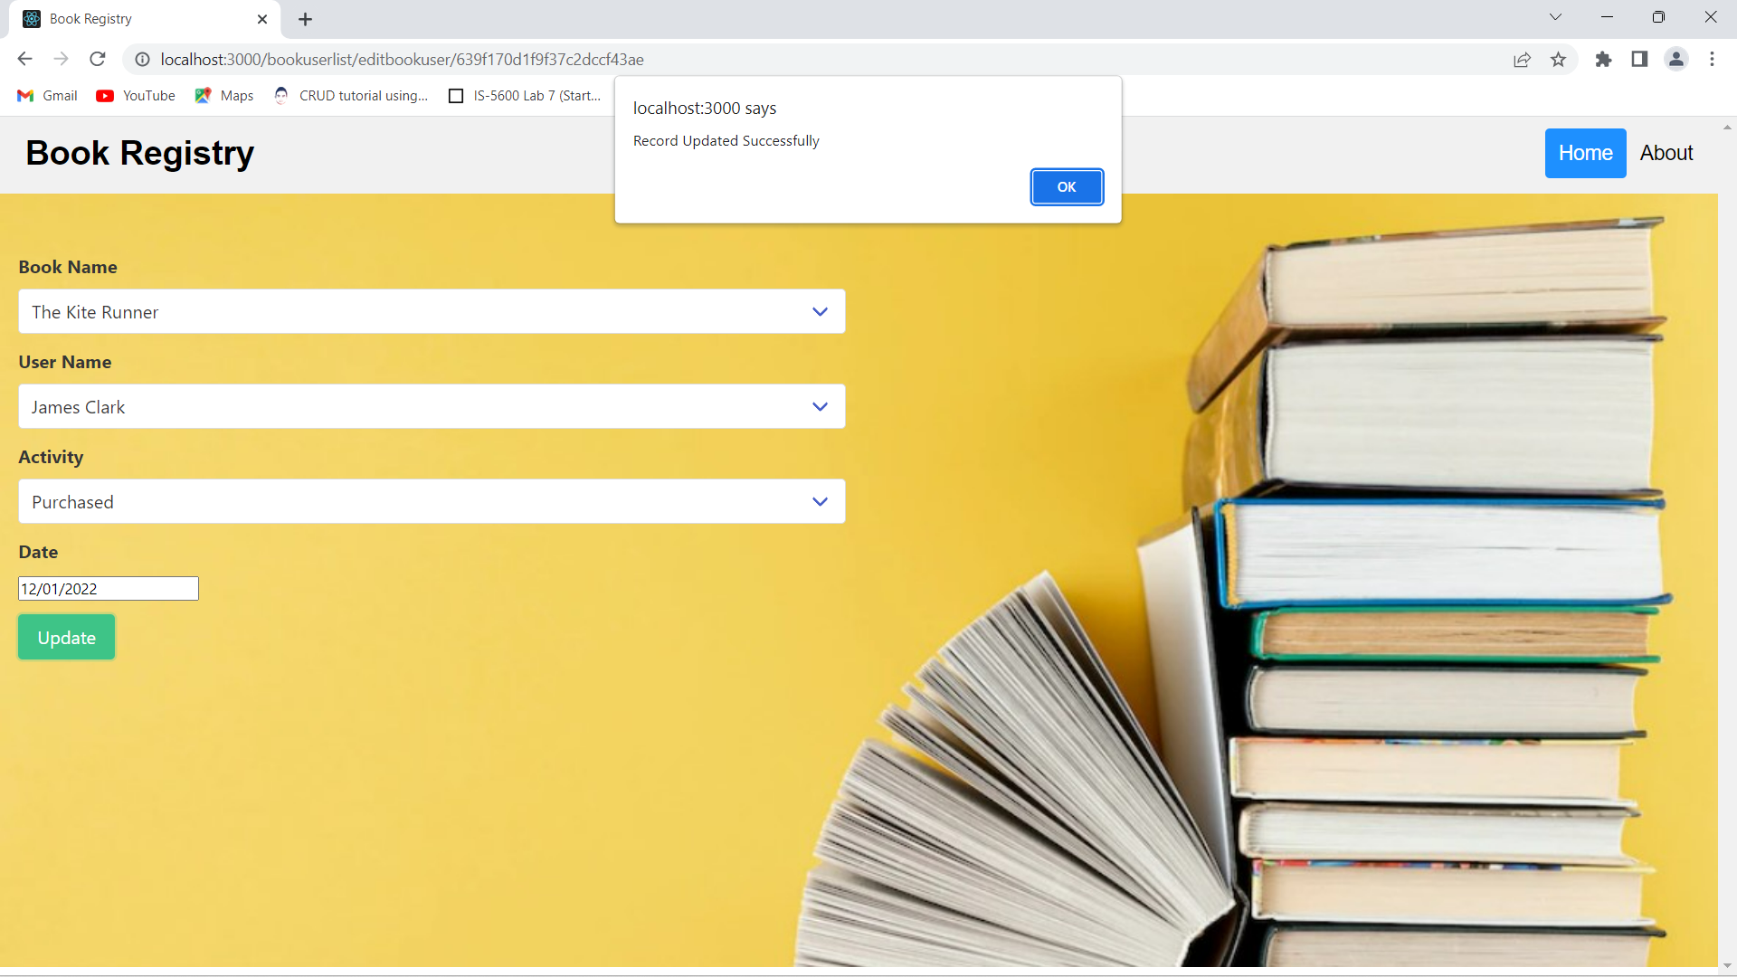

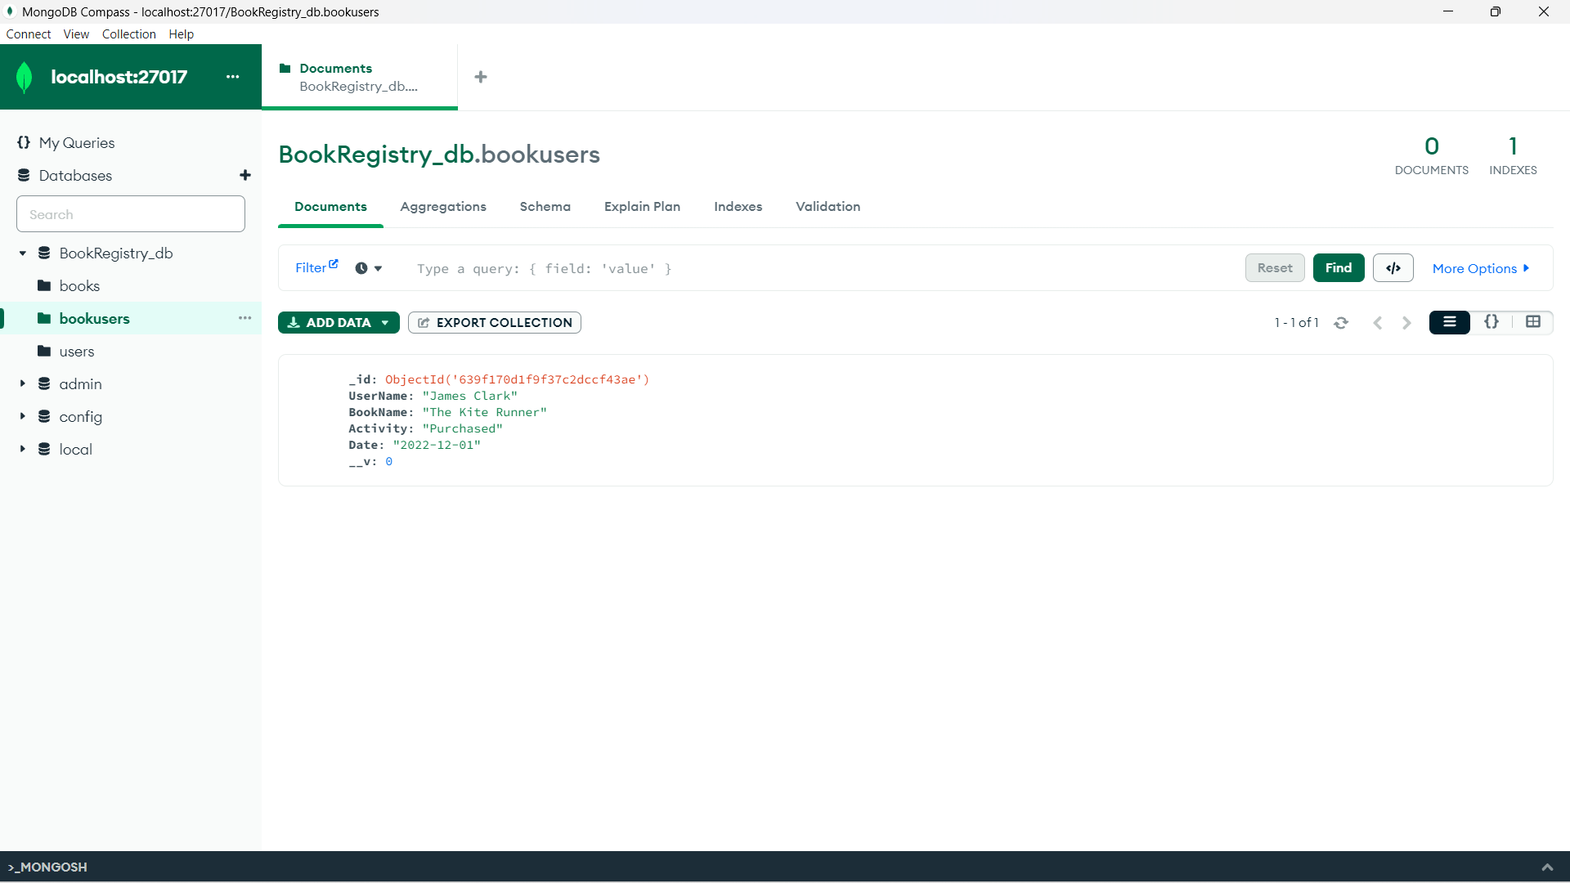

1. We have added more records of book users.

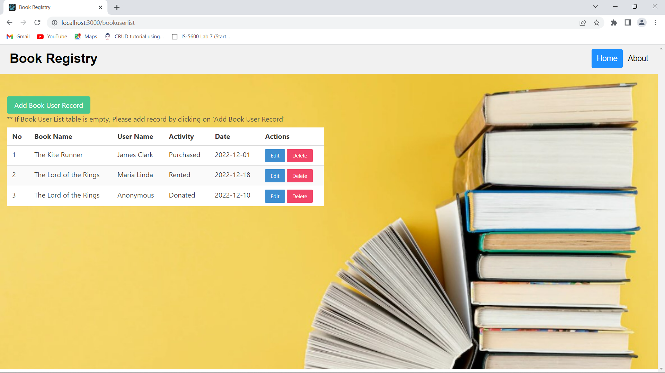

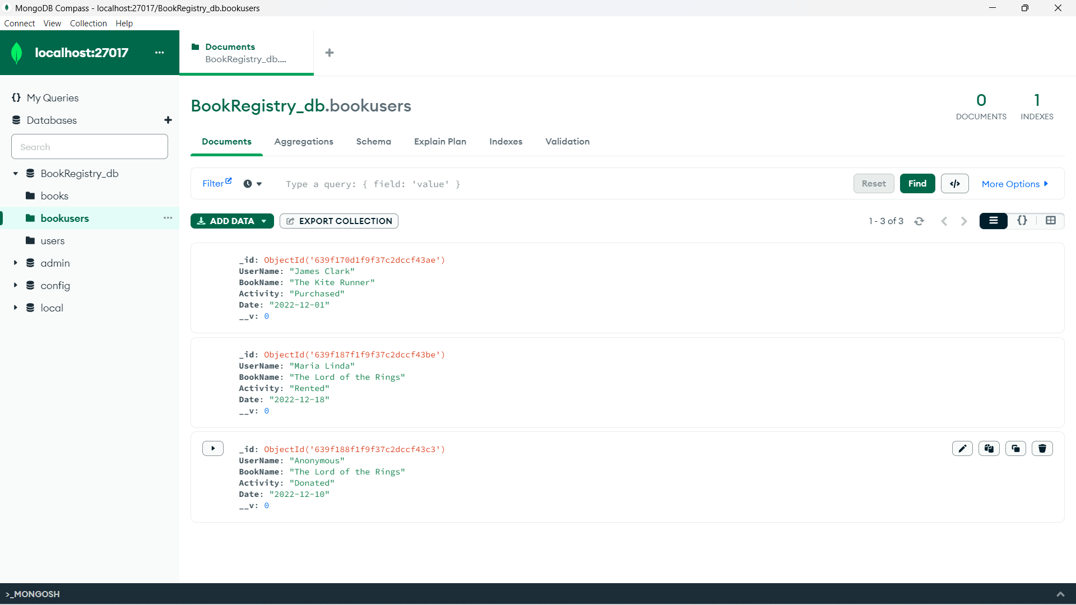

1. Now let’s delete ‘The Lord of the Rings’ Rented activity of ‘Maria Linda’ from the list by clicking on **Delete** button.

